

ASSET VERIFICATION AND RECORDING TOOL KIT


Plot 31, Bukoto Street
P.O Box 7657, Kampala, Uganda
+256 (0) 39 2000216/0772525235
email: cpa@cpa.ug

www.cpa.com

August to September 2026

VERIFICATION DETAILS

NAME OF THE REGION: | WESTERN
SUB-REGION: | TOORO
Name of Local Government | MUBENDE LOCALGOVERNMENT
VERIFIER PARTICULARS
Full name | JALIYAH BALUUBU
Contact/ email and Telephone | Jaliahb45@gmail.com  0794775877
Supervisor/ Sub team leader
Name | Prof: MBONIGABA DEPAUL
Contact | 0788483159
Date of submission | 06/09/2026

HEALTH CENTRES
INFORMANT INTERVIEW/DISCUSSION GUIDE (INCHARGE OR RESPONSIBLE PERSON)

Name of Health Centre: GAYAZA HEALTH CENTRE III

1a | Does the Facility have a record of all assets provided under UgIFT.  (Obtain a record and verify if it has the costs and numbers supplied | yes
1b | If Not ask how many were supplied and when.

2 | How does this facility Maintain (repair/service/replace) the assets provided under Ugift

The facility has a dedicated budget for repairs/replacements as well as receiving financial help from mubende RRH

3 | Does the facility take regular record about functionality/ or breakdown of the assets provided? | YES

The facility provided a register of all items that were delivered although most of them were still in storage due to electricity issues. There was no damaged item.

4 | How has the UgIFT support helped in service delivery in the area, any issues, challenges and any recommendations for better program implementation.

The incharge expressed gratitude to the UGIFT program for reaching out to provide the most crucial equipment in saving lives hence easing their mandate as health workers.

The incharge complained about the provision of electronic devises without providing power supply which has hindered the use of the most equipment.

She also complained that the assets delayed so much at the district quarters and some assets were below the signed quantity.

She further stated that the solar system that was provided only works during day, it was supposed to have 6 batteries but only got 3 which has paralyzed their night works due to electricity issues.

She recommended that the program should find alternative ways to provide with them electricity and water so as to enable full usage of the equipment that was provided

The incharge further recommended that there should a consideration of providing safety cabinets for laboratory tests.

PROCEED TO VERIFICATION AFTER THIS DISCUSSION

Health centre checklist

NAME OF LG MUBENDE
NAME OF HEALTH FACILITY GAYAZA HEALTH CENTER III

Equipment/ Item | Department | Asset Number | Item  Description | Life in Months | Tag Number ( engrave no.) | Date Of Purchase | Date Placed In Service | Recoverable cost | Cost | Acc Dep Cost | Net Book Value | Ytd Deprn | Equipment status | Remarks
B.P. Machine, Digital | Health |  | White in color with a screen and a plastic frame |  | Not engraved |  |  |  |  |  |  |  | Functional | In use
 | Health |  | White in color with a screen and a plastic frame |  | Not engraved |  |  |  |  |  |  |  | Functional | In use
B.P. Machine (Aneroid wall mounted) | Health |  | Navy blue, has a bulb and tubing, has a black pulse rate connected on an arm cuff on a holder |  | Not engraved |  | 22.06.21 |  |  |  |  |  | Functional | In use
 | Health |  | Navy blue, has a bulb and tubing. |  | Not engraved |  | 22.06.21 |  |  |  |  |  | Functional | In use
Autoclave 20 Liters.,Duo Operated | Health |  | Cylindrical drum made of stainless steel with a heavy cover with black pressure valves. MS-151 |  | MLG/GYZ/HCIII |  | 22.06.21 |  |  |  |  |  | Functional | Manually in use
 | Health |  | Cylindrical drum made of stainless with a heavy cover with black pressure valves |  | MLG/GYZ/HCIII |  | 22.06.21 |  |  |  |  |  | Not yet functional | Not in use due to electricity issues.
Bowl, Kick
Bowl Stand | Health |  | A double bowl stainless steel device |  | Not engraved |  | 13.10.21 |  |  |  |  |  | Functional | In use
 | Health |  | A double bowl stainless steel device |  | Not engraved |  | 13.10.21 |  |  |  |  |  | Functional | In use
Counting chamber Neubauer- Improved
Cupboard Steel, Lockable
Drip Stand | Health |  | A medical device used to hold and support bottles or bags of fluids, medication, blood products during patient care |  | MLG/GYZ/HCIII |  | 13.10.21 |  |  |  |  |  | Functional | In use
 | Health |  | A medical device used to hold and support bottles or bags of fluids. |  | MLG/GYZ/HCIII |  | 13.10.21 |  |  |  |  |  | Functional | In use
 | Health |  | A medical device used to hold and support bottles or bags of fluids |  | MLG/GYZ/HCIII |  | 13.10.21 |  |  |  |  |  | Functional | In use
 | Health |  | A medical device used to hold bags of fluids. |  | MLG/GYZ/HCIII |  | 13.10.21 |  |  |  |  |  | Functional | In use
 | Health |  | A medical tool used to hold and support bags and bottles of fluids |  | MLG/GYZ/HCIII |  | 13.10.21 |  |  |  |  |  | Functional | In use
 | Health |  | A medical tool used to hold and support bags and bottles of fluids |  | MLG/GYZ/HCIII |  | 13.10.21 |  |  |  |  |  | Functional | In use
 | Health |  | A medical tool used to hold and support bags and bottles of fluids |  | MLG/GYZ/HCIII |  | 13.10.21 |  |  |  |  |  | Functional | In use
ESR Stand | Health |  | A tool used to hold blood collection tubes completely vertical during a sed rate test | 24.04.22 | MLG/GYZ/HCIII |  | 13.10.21 |  | 323,500.00 |  | 323,500.00 |  | Not yet functional | Still in store
Examination Couch | Health |  | 1 black padded bed with a stainless steel stands which is raisable |  | Not engraved |  | 13.10.21 |  |  |  |  |  | Functional | In use
 | Health |  | 1 black padded bed with stainless steel stand and raisable |  | Not engraved |  | 13.10.21 |  |  |  |  |  | Functional | In use
 | Health |  | 1 black padded bed with stainless steel stand and raisable |  | Not engraved |  | 13.10.21 |  |  |  |  |  | Functional | In use
Examination light,LED | Health |  | 1 specialized medical light that provides bright, focused and cool illumination for patient check up and minor surgeries. KS-Q6 |  | MLG/GYZ/HCIII |  | 13.10.21 |  | 694,500 |  | 2,083,500.00 |  | Functional | In use
 | Health |  | 1 specialized medical light that provides bright, focused and cool illumination for patient check up and minor procedures. KS-Q6 |  | MLG/GYZ/HCIII |  | 13.10.21 |  | 694,500 |  | 2,083,500 |  | Functional | In use
 | Health |  | 1 specialized medical light that provides bright, focused and cool illumination for patient check up and minor surgeries. KS-Q6 |  | MLG/GYZ/HCIII |  | 13.10.21 |  | 694,500 |  | 2,083,500 |  | Functional | In use
Glucometer | Health |  | Hand held electronic device with a small screen, a slot where you insert a test trip and button for control |  | Not engraved |  | 22.06.21 |  |  |  |  |  | Not functional
 | Health |  | Hand held electronic device with a small screen where you insert a test trip and button for control |  | Not engraved |  | 22.06.21 |  |  |  |  |  | Not functional
Haemoglobin Meter, Digital | Health |  | 1 small portable electronic device used to measure the concentration of haemoglobin | 24.04.22 | Not engraved |  | 13.10.21 |  | 368,700.00 |  | 737,400.00 |  | Not yet functional | Still in store
 | Health |  | 1 small portable electronic device used to measure the concentration of haemoglobin | 24.04.22 | Not engraved |  | 13.10.21 |  |  |  |  |  | Not yet functional | Still in store
Height Meter | Health |  | 1 long ruler like height measuring board. |  | MLG/GYZ/HCIII |  | 22.06.21 |  |  |  |  |  | Functional | In use
Instrument Trolley | Health |  | Stainless steel instrument with two shelves |  | MLG/GYZ/HCIII |  | 22.06.21 |  |  |  |  |  | Functional | In use
 | Health |  | Stainless steel with two shelves |  | MLG/GYZ/HCIII |  | 22.06.21 |  |  |  |  |  | Functional | In use
 | Health |  | Stainless steel with two shelves |  | MLG/GYZ/HCIII |  | 22.06.21 |  |  |  |  |  | Functional | In use
Microscope Binocular | Health |  | 1 olympus microscope LE-052 |  | MLG/GYZ/HCIIII |  | 22.06.21 |  |  |  |  |  | Functional | In use
Otoscope
Patient Screen | Health |  | 1 patient blue with white stands F-35 |  | Not engraved |  | 22.06.21 |  |  |  |  |  | Functional | In use
 | Health |  | 1 patient blue with White stands F-35 |  | Not engraved |  | 22.06.21 |  |  |  |  |  | Functional | In use
 | Health |  | 1 patient blue with white stands F-35 |  | Not engraved |  | 22.06.21 |  |  |  |  |  | Functional | In use
 | Health |  | 1 patient blue with white stands F-35 |  | Not engraved |  | 22.06.21 |  |  |  |  |  | Functional | In use
 | Health |  | 1 patient blue with white F-35 |  | Not engraved |  | 22.06.21 |  |  |  |  |  | Functional | In use
Patient Trolley | Health |  | Stainless steel stands padded with a black bed |  | MLG/GYZ/HCIII |  | 22.06.21 |  |  |  |  |  | Functional | In use
 | Health |  | Stainless steel stands padded with a black bed |  | MLG/GYZ/HCIII |  | 22.06.21 |  |  |  |  |  | Functional | In use
Refrigerator, Basic | Health |  | One cream like refrigerator. LE-273 |  | Not engraved |  | 22.06.21 |  |  |  |  |  | Functional but not operating | Not operating due to electricity issues
Stethoscope | Health |  | A stainless steel rod padded with a black cot used to listen to internal sounds of human |  | Not engraved |  | 22.06.21 |  |  |  |  |  | Functional | In use
 | Health |  | A stainless steel padded with a black rod used to listen to internal sounds |  | Not engraved |  | 22.06.21 |  |  |  |  |  | Functional | In use
 | Health |  | A stainless steel padded with a black cot used to listen to internal sounds |  | Not engraved |  | 22.06.21 |  |  |  |  |  | Functional | In use
 | Health |  | A stainless steel with a black padded rod used to listen to internal sounds |  | Not engraved |  |  |  |  |  |  |  | Functional | In use
Stop Watch | Health |  | One digital timer. LE-256 |  | Not engraved |  | 22.06.21 |  |  |  |  |  | Functional | Still in store
Stretcher | Health |  | I stainless steel with adjustable height. E-5 |  | MLG/GYZ/HCIII |  | 13.10.2021 |  | 4,748,000 |  | 4,748,000 |  | Functional | In use
Stove, Gas | Health |  | Stove gas OT-20 |  | Not engraved |  | 22.06.21 |  |  |  |  |  | Functional | In use
 | Health |  | Stove gas OT-20 |  | Not engraved |  | 22.06.21 |  |  |  |  |  | Functional | In use
Weighing Scale with Height Meter, Adult | Health |  | Heavy duty steel platform, aluminum height rod, rubber mat |  | MLG/GYZ/HCIII |  |  |  |  |  |  |  | Functional | In use
Weighing Scale, Infant | Health |  | Bowl/tray type battery operated scale |  | MLG/GYZ/HCIII |  | 13.10.2021 |  |  |  |  |  | Functional | In use
 | Health |  | Bowl/tray type battery operated scale |  | MLG/GYZ/HCIII |  | 13.10.2021 |  |  |  |  |  | Functional | In use
Weighing Scale, Toddler | Health |  |  |  | MLG/GYZ/HCIII |  | 13.10.2121 |  |  |  |  |  | Functional | In use
Wheel Chair | Health |  | 1 black wheel chair with stainless stands |  | Not engraved |  | 13.10.2021 |  | 477,800.00 |  | 1,911,200 |  | Functional | In good shape
 | Health |  | I black wheel chair with stainless steel stands |  | Not engraved |  | 13.10.2021 |  | 477,800.00 |  | 1,911,200 |  | Functional | In good shape
Audio Visual Equipment | Health |  | 1 audio visual tool that helps people learn by using both hearing and seeing at the same time. |  | Not engraved |  | 13.10.2021 |  | 8,082,700 |  | 8,082,700 |  | Functional but not operational | In good shape but still in store due to electricity issues
Medical Waste Bin | Health |  | Plastic, brown with covers |  | MLG/GYZ/HCIII |  | 13.10.21 |  |  |  |  |  | Functional | In good shape and in use
 | Health |  | Plastic, brown with covers |  | MLG/GYZ/HCIII |  | 13.10.21 |  |  |  |  |  | Functional | In good shape and in use
 | Health |  | Plastic, brown with covers |  | MLG/GYZ/HCIII |  | 13.10.21 |  |  |  |  |  | Functional | In a good shape and in use
 | Health |  | Plastic, brown with covers |  | MLG/GYZ/HCIII |  | 13.10.21 |  |  |  |  |  | Functional | In a good shape and in use
 | Health |  | Plastic, brown with covers |  | MLG/GYZ/HCIII |  | 13.10.21 |  |  |  |  |  | Functional | In a good shape and in use
 | Health |  | Plastic, brown with covers |  | MLG/GYZ/HCIII |  | 13.10.21 |  |  |  |  |  | Functional | In a good shape and in use
Wall Clock | Health |  | A round clock operating on batteries |  | Not engraved |  | 13.10.21 |  |  |  |  |  | Functional | In use
 | Health |  | A round clock operating on batteries |  | Not engraved |  | 13.10.21 |  |  |  |  |  | Functional | In use
Diagnostic Equipment Set for MCH
Diagnostic Equipment Set for OPD | Health |  | I group of non-sterile instruments and devices in the OPD examination room |  | Not engraved |  | 13.10.2021 |  | 251,000 |  | 502,000 |  | functional | In good shape
 | Health |  | 1 group of non-sterile instruments and devices in the OPD examination room |  | Not engraved |  | 13.10.2021 |  | 251,000 |  | 502,000 |  | Functional | In good shape
Glassware Set, Laboratory, Basic | Health |  | A set of glass apparatus used in the laboratory. MIS-129 |  | Not engraved |  | 13.10.2021 |  | 323,500 |  | 647,000 |  | Functional but not yet operational | Still in store
 | Health |  | A set of glass apparatus used in the laboratory. MIS-129 |  | Not engraved |  | 13.10.2021 |  | 323,500 |  | 647,000 |  | Functional but not yet o[perational | Still in store
Hollow Ware Set, Treatment | Health |  | A set of stainless steel equipment. MIS-122 |  | Not engraved |  | 13.10.2021 |  | 1,710,600 |  | 1,710,600 |  | Functional | In store
Instrument Set, Dressing | Health |  | Stainless steel containing all equipment |  | Not engraved |  | 13.10.2021 |  | 252,900 |  | 1,770,300 |  | Functional | In good shape
 | Health |  | Stainless steel containing all equipment |  | Not yet engraved |  | 13.10.2021 |  | 252,900 |  | 1,770,600 |  | functional | In good shape
Instrument Set, Basic ENT | Health |  | 1 set of stainless instrument, auto clavable stainless steel |  | Not engraved |  | 13.10.2021 |  | 1,842,300 |  | 1,842,300 |  | Functional | In good shape
Instrument Set, Suture | Health |  | 1 small set of ready packed sterilized instruments for stitching or surgical incision. MIS-125 |  | Not engraved |  | 13.10.2021 |  | 375,900 |  | 1,127,700 |  | Functional | In good shape
 | Health |  | 1 small set of ready packed sterilized instruments for stitching or surgical incision. MIS-125 |  | Not engraved |  | 13.10.2021 |  | 375,900 |  | 1,127,700 |  | Functional | In good shape
Pulse Oximeter, Hand held | Health |  | 1 small painless medical device that clips onto the finger to measure the amount of oxygen in blood |  | Not engraved |  | 13.10.21 |  |  |  |  |  | Functional | In use
 | Health |  | 1 small painless medical device that clips onto the finger to measure the amount of oxygen in blood |  | Not engraved |  | 13.10.21 |  |  |  |  |  | Functional | In use
Bed, Adult Patient with Mattress | Health |  | 1 pair of a metallic bed with a black padded mattress1 pair of a metallic bed with a black padded mattress |  | MLG/GYZ/HCIII |  | 13.10.2021 |  |  |  |  |  | Functional | In good shape and in use
 | Health |  | 1 pair of a metallic bed with a black padded mattress |  | MLG/GYZ/HCIII |  | 13.10.2021 |  |  |  |  |  | Functional | In good shape and in use.
 | Health |  | 1 pair of a metallic bed with a black padded mattress |  | MLG/GYZ/HCIII |  | 13.10.2021 |  |  |  |  |  | Functional | In good shape and in use
 | Health |  | 1 pair of a metallic bed with a black padded bed |  | MLG/GYZ/HCIII |  | 13.10.2021 |  |  |  |  |  | Functional | In good shape and in use
 | Health |  | 1 pair of a metallic bed with a black padded mattress |  | MLG/GYZ/HCIII |  | 13.10.2021 |  |  |  |  |  | Functional | In good shape
 | Health |  | 1 pair of a metallic bed with a black padded mattress |  | MLG/GYZ/HCIII |  | 13.10.2021 |  |  |  |  |  | Functional | In good shape
 | Health |  | 1 pair of a metallic bed with a black padded mattress |  | MLG/GYZ/HCIII |  | 13.10.2021 |  |  |  |  |  | Functional | In good shape
 | Health |  | 1 pair of a metallic bed with a black padded mattress |  | MLG/GYZ/HCIII |  | 13.10.2021 |  |  |  |  |  | Functional | Already in use
 | Health |  | 1 pair of a metallic bed with a black padded mattress |  | MLG/GYZ/HCIII |  | 13.10.2021 |  |  |  |  |  | Functional | Already in use
 | Health |  | 1 pair of a metallic bed with a black padded mattress |  | MLG/GYZ/HCIII |  | 13.10.2021 |  |  |  |  |  | Functional | Already in use
Bed, Pediatric Patient, With Mattress | Health |  | Black mattress side rails, pink and blue, gray with a drip stand |  | MLG/GYZ/HCIII |  | 13.10.2021 |  |  |  |  |  | Functional | In good shape
 | Health |  | Black mattress, side rails pink and blue, grey with a drip stand |  | MLG/GYZ/HCIII |  | 13.10.2021 |  |  |  |  |  | Functional | In good shape
 | Health |  | Black mattress side rails pink, blue, gray with a drip stand |  | MLG/GYZ/HCIII |  | 13.10.2021 |  |  |  |  |  | Functional | In good shape
 | Health |  | Black matress side rails pink, blue, gray with a drip stand |  | MLG/GYZ/HCIII |  | 13.10.2021 |  |  |  |  |  | Functional | In good shape
 | Health |  | Black mattress side rails pink, blue, gray with a drip stand |  | MLG/GYZ/HCIII |  | 13.10.2021 |  |  |  |  |  | Functional | In good shape
Bedside Locker
Cupboard, Instrument | Health |  | 1 Gray steel with shelves inside |  | MLG/GYZ/HCIII |  | 13.10.2021 |  |  |  |  |  | Functional | In use and good shape
 | Health |  | 1 gray steel with shelves inside |  | MLG/GYZ/HCIII |  | 13.10.2021 |  |  |  |  |  | Functional | In use and in good shape
Delivery Bed, Hydraulic Manual | Health |  | I blue padded surface, washable delivery hydraulic bed. MT 400 |  | Not engraved |  | 13.10.2021 |  |  |  |  |  | Functional | In good shape and in use
Oxygen Therapy Apparatus, Mininum 45L cylinder | Health |  | Oxygen gas cylinder |  | MLG/GYZ/HCIII |  | 13.10.21 |  |  |  |  |  | Functional | In use
 | Health |  | Oxygen gas cylinder |  | MLG/GYZ/HCIII |  | 13.10.21 |  |  |  |  |  | Functional | In use
Resuscitator Manual, Infant, with all Mask sizes
Resuscitator Manual, Adult, with all mask sizes
Suction Apparatus, (Electric) | Health |  | A medical device with two jars, suction tubing, foot pedal |  | MLG/GYZ/HCIII |  | 13.10.21 |  |  |  |  |  | Not functioning | The facility is using the manual device version due to electricity issues
Suction catheters | Health |  | A thin flexible tube used to clear mucus, blood, and fluids from a patient’s airway |  | Not engraved |  | 13.10.21 |  |  |  |  |  | Functional | In store
Nebulizer, Ultrasonic | Health |  | Has mask, mouth piece, air tubing medication caps |  | MLG/GYZ/HCIII13.10.21 |  |  |  |  |  |  |  | Functioning but still in store | Still in store
Oxygen Concentrator, Duo Flow | Health | 20210722263 | 1 white electronic machine that takes in normal room air and delivers pure oxygen. AB055 |  | MLG/GYZ/HCIII |  | 13.10.2021 |  |  |  |  |  | Not yet functional | In good shape but not yet in use due to electricity issues.
Bench | Health |  | A long wooden varnished bench |  | MLG/GYZ/HCIII |  | 13.10.21 |  |  |  |  |  | Functional | In use
 | Health |  | A long wooden varnished bench |  | MLG/GYZ/HCIII |  | 13.10.21 |  |  |  |  |  | Functional | In use
 | Health |  | A long wooden varnished bench |  | MLG/GYZ/HCIII |  | 13.10/21 |  |  |  |  |  | Functional | In use
 | Health |  | A long wooden varnished bench |  | MLG/GYZ/HCIII |  | 13.10.21 |  |  |  |  |  | Functional | In use
Disinfection Buckets | Health |  | Plastic, red with covers |  | MLG/GYZ/HCIII |  | 13.10.2021 |  |  |  |  |  | Functional | In good shape
 | Health |  | Plastic, yellow with covers |  | MLG/GYZ/HCIII |  | 13.10.2-021 |  |  |  |  |  | Functional | In good shape
Baby Cot | Health |  | Rectangular small bed for infants of steel frame with drop sides, a mattress and wheels |  | Not engraved |  | 13.10.21 |  |  |  |  |  | Functional but not yet operational | Electricity issues
 | Health |  | Rectangular small bed for infants of steel frame with drop sides, a mattress and wheels |  | Not engraved |  | 13.10.21 |  |  |  |  |  | Functional but not yet operational | Electricity issues
 | Health |  | Rectangular small bed for infants of steel frame with drop sides, a mattress and wheels |  | Not engraved |  | 13.10.21 |  |  |  |  |  | Functional but not yet operational | Electricity issues
 |  |  | Rectangular small bed for infants with steel frame with drop sides, mattress and wheels |  | Not engraved |  | 13.10.21 |  |  |  |  |  | Functional but not operational | Due to electricity issues
Diagnostic Equipment Set for Ward | Health |  | 1 set of instruments used for basic examinations kept together in the ward for routine patient assessment. MIS. 121 | 31.03.2024 | Not engraved |  | 13.10.2021 |  |  |  |  |  | Functional | Received a total of 5 sets in good shape
 | Health |  | 1 set of instruments used for basic examinations kept together in the ward for routine patient assessment. MIS.121 | 31.03.2024 | Not engraved |  | 13.10.2021 |  |  |  |  |  | Functional | In good shape
Instrument Set, Delivery | Health |  | 1 set of a already sterilized of instruments packed for conducting a normal vaginal delivery and caring for the newborn cord | 31.03.2024 | Not engraved |  | 13.10.2021 |  |  |  |  |  | functional | In good shape and already in use
Hollow Ware Set, Ward | Health |  | 1 set of stainless steel containers including bowls, trays, used for carrying, holding and disposing of materials during procedures. MS-123 | 31.03.2024 | Not engraved |  | 13.10.2021 |  |  |  |  |  | Functional | In good shape and in shape
 | Health |  | 1 set of already sterilized instruments packed for conducting a normal vaginal delivery and caring for the newborn cord | 31.03.2024 | Not engraved |  | 13.10.2021 |  |  |  |  |  | Functional
 | Health |  | 1 set of already sterilized instruments packed for conducting a normal vaginal delivery and caring for a newborn cord | 31.03.2024 | Not engraved |  | 13.10.2021
Instrument Set, Stitch Removing | Health | 1C218AS0000191 | 1 small light scissors made of stainless steel. MIS-126 | 31.03.2024 | Not engraved |  | 13.10.2021 |  |  |  |  |  | Functional | In goog shape
 | Health | 1C218AS0000191 | 1 small light scissors made of stainless steel. MIS-126 | 31.03,2024 | Not engraved |  | 13.10.2021 |  |  |  |  |  | Functional | In good shape
 | Health | 1C218AS0000191 | 1 small light scissors made of stainless steel. MIS-126 | 31.03.2024 | Not engraved |  | 13.10.2021 |  |  |  |  |  | Functional | In good shape
 | Health | 1C218AS0000191 | 1 small light scissors made of stainless steel. MIS-126 | 31.03.2024 | Not engraved |  | 13.10.2021 |  |  |  |  |  | functional | In good shape
MVA Kit | Health |  | Not applicable |  | Not applicable |  |  |  |  |  |  |  | Not applicable | Never recieved
Stool, Laboratory | Health |  | A black high end height adjustable stool. MF-671 |  | Not engraved |  |  |  |  |  |  |  | Not applicable | Never recieved
Penguin Sucker | Health | IC218AS0000191 | I white penguin like shaped reusable suction used to clear mucus/fluids and secretions from a newborns’ nose and mouth | 31.03.2024 | Not engraved |  | 13.10.2021 |  | 55,200 |  | 165,600 |  | Not functional | In a good shape but not in use due to electricity issues
 | Health | IC218AS0000191 | 1 white penguin-like shaped reusable suction used to clear mucus/fluids and secretions from a newborns’ nose and mouth | 31.03.2024 | Not engraved | 13.10.2021 |  |  | 55,200 |  | 165,600 |  | Not functional | In good shape but not in use due to electricity issues
 | Health |  | 1 white penguin like shaped reusable suction used to clear mucus/fluids from the newborns’ nose and mouth | 31.03.2024 | Not engraved | 13.10.2021 |  |  | 55,200 |  | 165,600 |  | Not functional | In good shape but not in use due to electricity issues
Fetoscope, Dopplar
Bubble CPAP
Centrifuge (Electric) | Health | 1C218AS0000191 | 1 bench top centrifuge used for separation of blood components | 31.03.2024 | MLG/GYZ/HCIII |  | 13.10.2-021 |  |  |  |  |  | Functional | In good shape but still not in use due to electricity issues at the facility
Kangaroo Mother Care Chair | Health |  | 1 low, reclinable arm chair that allows comfortable sitting for mothers while holding their babies |  | Not engraved |  | 13.10.2021 |  |  |  |  |  | Not functional | In good shape but not yet in use due to lack of electricity
Radiant Infant Warmer
Haemoglobin Meter, Sahli | Health | HbM1010030 | 1 hemoglobin meter mission plus. LH-270 |  | Not engraved |  | 13.10.2021 |  |  |  |  |  | Not functional | Not in use yet, still in storage
 | Health | HbM1010030 | I hemoglobin meter mission plus. LH-270 |  | Not engraved. |  | 13.10.2021 |  |  |  |  |  | Not functional | Not in use yet. Still in store
Delivery Bed | Health |  | 1 delivery hydraulic bed MT-400 |  | Not engraved |  | 08.11.2021 |  |  |  |  |  | Not functional | In good shape but not yet in use.
Examination light
Instrument set, ENT Basic for HCIII | Health | M21711830018/M2171830019 | 1 set of basic instruments used for basic examinations MIS-127 |  | Not engraved |  | 13.10.21 |  |  |  |  |  | Functioal | In good shape
Bag Valve mask (Ambu Bag), Neonatal | Health | M010070504 | 1 Ambu bag silicone kit for infants. AB065 |  | Not engraved |  | 08.11.2021 |  |  |  |  |  | Never recievedl | Never recieved
Incubator
Office Chair
 | Health |  | 1 black electronic chair. OT.65 |  | Not engraved |  | 13.10.2021 |  |  |  |  |  | Functional but not engraved | The chair is in good shape and in use
 | Health |  | 1black electronic chair. OT. 65 |  | Not engravede |  | 13.10.2021 |  |  |  |  |  | functional | In good shape and in use
 | Health |  | 1 black electronic chair. OT. 65 |  | Not engraved |  | 13.10.21 |  |  |  |  |  | functional | In good shape and in use
 | Health |  | 1 wooden varnished chair. OT. 65 |  | MLG/GYZ/HCIII |  | 13.10.21 |  |  |  |  |  | Functioning and engraved | In good shape and in use
 | Health |  | 1 wooden varnished chair. OT.65 |  | MLG/GYZ/HCIII |  | 13.10.21 |  |  |  |  |  | functioning | In good shape and in use
 | Health |  | 1 wooden varnished chair. OT.65 |  | MLG/GYZ/HCIII |  | 13.10.21 |  |  |  |  |  | functioning | In good shape and in use
 | Health |  | 1wooden varnished chair. OT.65 |  | MLG/GYZ/HCIII |  | 13.10.21 |  |  |  |  |  | functioning | In good shape and in use
Desk | Health |  | 1 wooden varnished long desk. OT.66 | 18.01.2023 | MLG/GYZ/HCIII/FY2021/2022 |  | 13.10.21 |  |  |  |  |  | Functional | In good shape and already in use
 | Health |  | 1 wooden varnished long desk. OT.66 | 18.01.2023 | MLG/GYZ/HCIII/FY2021/2022 |  | 13.10.21 |  |  |  |  |  | functional | In good shape and in use
 | Health |  | 1 wooden varnished desk. OT.66 | 18.01.2023 | MLG/GYZ/HCIII/FY2021/2022 |  | 13.10.21 |  |  |  |  |  | Functioning | In good shape
 | Health |  | 1 wooden varnished desk. OT.66 | 18.01.23 | MLG/GYZ/HCIII/FY1021/2022 |  | 13.10.21 |  |  |  |  |  | Functioning and engraved | In good shape and already in use
Filing Cabinet | Health |  | A cupboard like furniture with shelves used for storage. MF-641 |  | MLG/GYZ/HCIII |  | 13.10.21 |  |  |  |  |  | Functional | In use
 | Health |  | A cupboard like furniture with shelves used for storage. MF-641 |  | MLG/GYZ/HCIII |  | 13.10.21 |  |  |  |  |  | Functional | In use
 | Health |  | A cupboard like tool with shelves used for storage. MF-641 |  | MLG/GYZ/HCIII |  | 13.10.21 |  |  |  |  |  | Functional | In use
 | Health |  | A cupboard like tool with drawers used for storage. MF-641 |  | MLG/GYZ/HCIII |  | 13.10.21 |  |  |  |  |  | Functional | In use
 | Health |  | A cupboard like tool with drawers used for storage. MF-641 |  | MLG/GYZ/HCIII |  | 13.10.21 |  |  |  |  |  | Functional | In use
Non Residential Buildings | Health |  | 1 maternity ward with 1 block of 14 rooms |  |  |  |  |  |  |  |  |  | functional | In use
 | Health |  | I renovated opd block |  |  |  |  |  |  |  |  |  | Renovation complete | In use
 | Health |  | Toilets of I block of 8 stances with a bathroom |  |  |  |  |  |  |  |  |  | Functional | In use
Residential Buildings
Water tanks | Health |  | Black water tank |  | Not engraved |  |  |  |  |  |  |  | Not functional | Connecting them to water supply is hard due to lack of electricity
 | Health |  | Black water tank |  | Not engraved |  |  |  |  |  |  |  | Not functional | Connecting them to water supply plant is hard due to lack of electricity.
Solar | Health | SN010201501224470028 | Solar panel |  | MLG/GYZ/HCIII |  |  |  |  |  |  |  | Partial fuctioning | Only workd during day

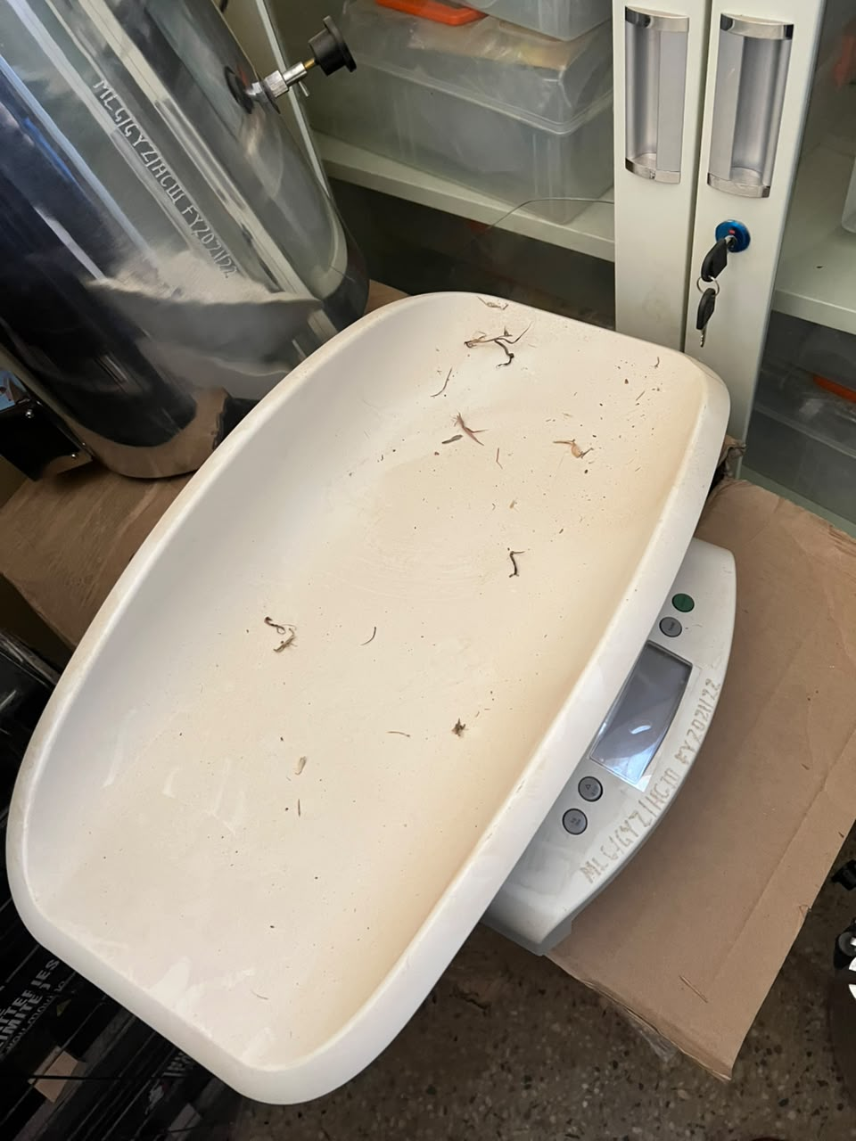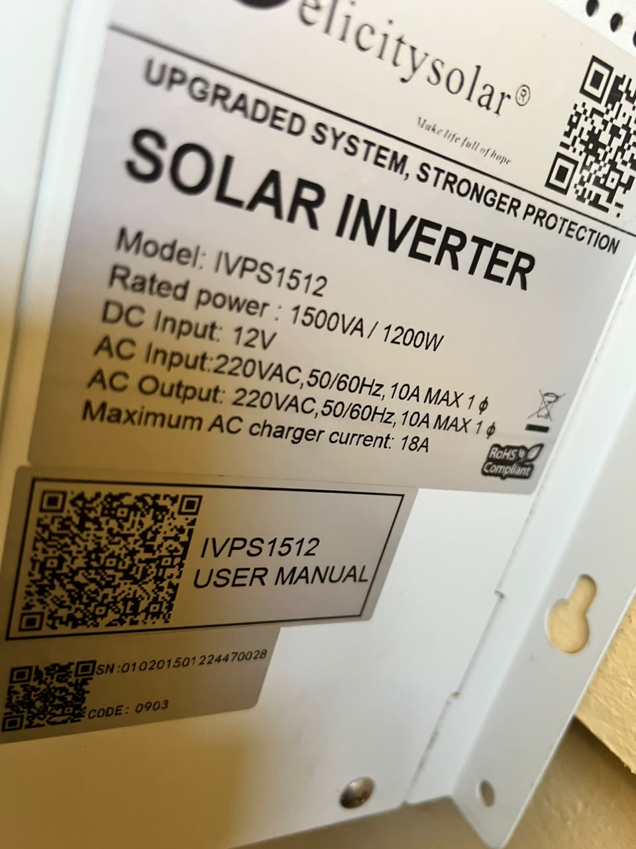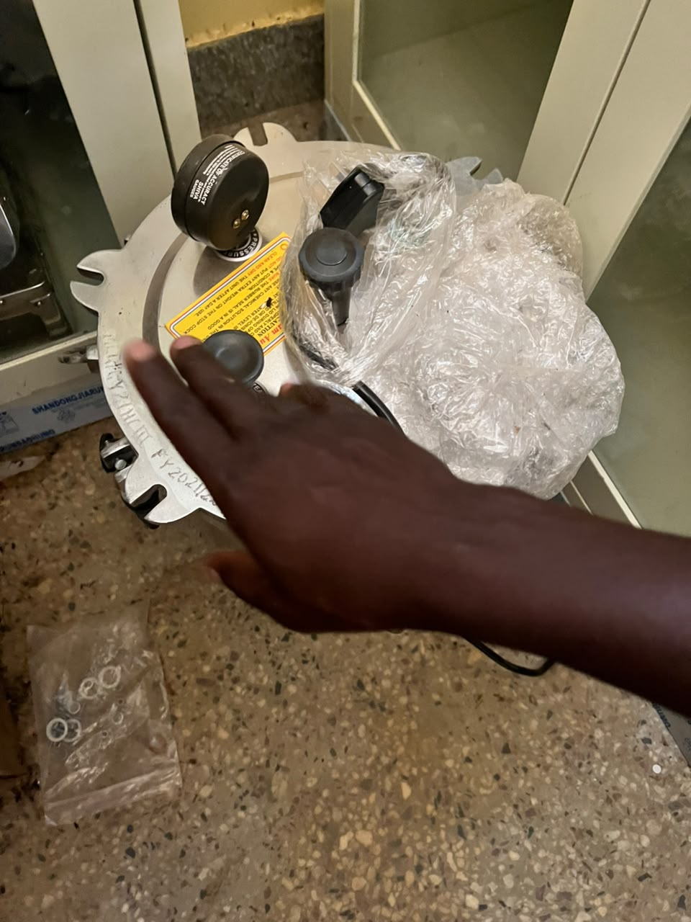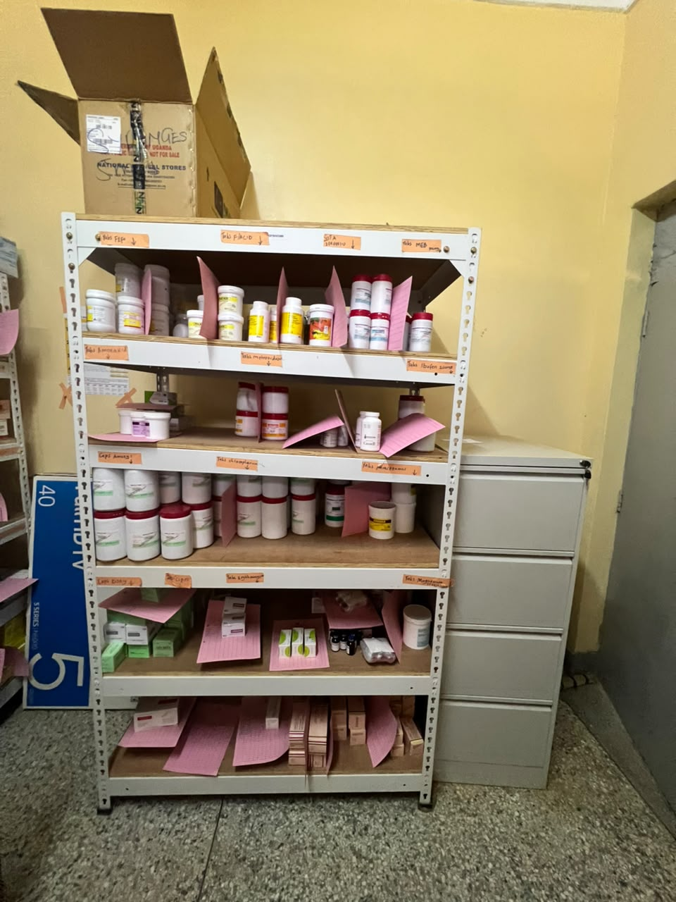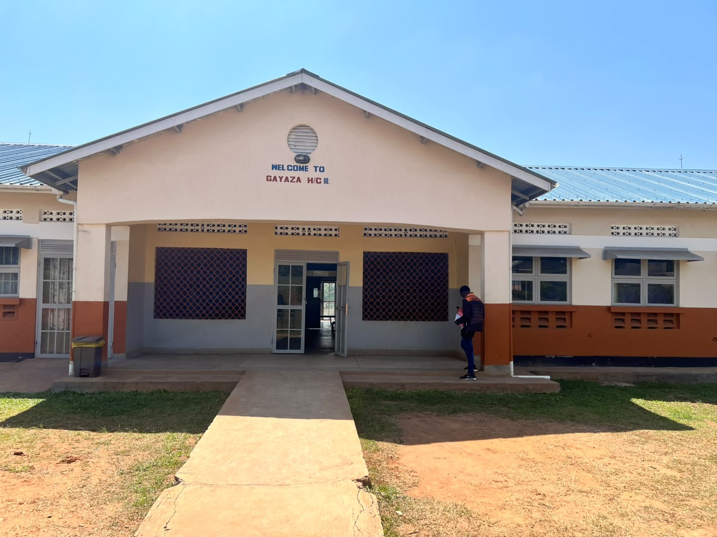
A baby weighing machine
solar
Auto clave

Open shelves alongside a filing cabinet
Maternity ward

SCHOOL VERIFICATION CHECKLIST

SCHOOL INTERVIEW/DISCUSSION GUIDE

Name of school: BUKUUKU COMMUNITY SECONDARY SCHOOL

1a | Does the Facility have a record of all assets provided under UgIFT.  (Obtain a record and verify if it has the costs and numbers supplied | yes
1b | If Not ask how many were supplied and when.

2 | How does this facility Maintain (repair/service/replace) the assets provided under Ugift

The school has a budget in their financial year school budget that was allocated to only maintaining and repairing the UGIFT assets in case of any damage through its specialists.

3 | Does the facility take regular record about functionality/ or breakdown of the assets provided?  Nonfunctional/ working, and reasons for non-functionality. | Not applicable

The UGIFT assets have not yet been fully handed over to the school administration since most of them are still work in progress.

4 | How has the UgIFT support helped in service delivery in the area, any issues, challenges and any recommendations for better program implementation.

With the construction of the laboratory and computer lab, the school saw an increase in enrollment of new students.

It has eased and improved on the teaching of science and computer subjects with the construction of the respective laboratories.

Recommedations
The contractor should speed up and handover the assets for full functioning and accountability.

The UGIFT program should consider providing stores for record keeping of students’ project work.

Challenges.
The school is located in an area with a poor drainage system which requires a water-plant for successful water supply

PROCEED TO VERIFICATION AFTER THIS DISCUSSION

SCHOOL FURNITURE
(School Desks, Office chairs, Laboratory stools, Book shelves)

Name of SCHOOL BUKUUKU COMMUNITY SECONDARY SCHOOL

Equipment/ Item | Department | Asset Number | Item  Description | Life in Months | Tag Number ( engrave no.) | Date Of Pur | Date Placed In Service | Recoverable cost | Cost | Acc Dep Cost | Net Book Value | Ytd Deprn | Equipment status | Remarks
School desks | Education |  | Wooden varnished desks |  | BUKCOMMSS-UGIFT-24-11  BUKCOMMSS-UGIFT-24-023  BUKCOMMSS-UGIFT-24-017  BUKCOMMSS-UGIFT-24-056  BUKCOMMSS-UGIFT-24-111 | l |  |  | 9,600,000 |  |  |  | Functioning and in good shape | The school received 120 engraved desks, all in good shape as shown in the pictures attached.
Office chairs | Education |  | Incomplete wooden varnished chairs |  |  |  |  |  |  |  |  |  | Not yet functioning. | The school is pending to receive 24 chairs which are still in the making stage.
Book shelves | Education |  | Incomplete wooden varnished shelves |  |  |  |  |  |  |  |  |  | Not yet functional | The school is yet to receive 19 book shelves which are still being made and not yet engraved.
Laboratory stools | Education |  | Incomplete wooden varnished desks |  | BUKCOMMSS-UGIFT-24-008  BUKCOMMSS-UGIFT-24-054  BUKCOMMSS-UGIFT-24-034  BUKCOMMSS-UGIFT-24-038 |  |  |  | 11,780,000 |  |  |  | Not yet functioning | The school will receive 120 already engraved stools upon the full completion of their making.
Lockable shelves | Education |  | unfinished |  |  |  |  |  | 2,775,000 |  |  |  | Not yet functioning | The school will receive 26 lockable shelves in the administration block. However their making is not yet complete and engraved.
Laboratory chairs | Education |  | Unfinished wooden varnished chairs |  |  |  |  |  |  |  |  |  | Not yet functioning | Not yet engraved, chairs still in the making process
Classroom tables | Education |  | unfinished |  |  |  |  |  |  |  |  |  | Not yet functioning | The school is set to receive 06 tables however they are not yet engraved.
Computer lab tables | Education |  | unfinished |  |  |  |  |  |  |  |  |  | Not yet functioning | The school upon finishing will receive well engraved 42 tables plus 2 teacher tables
Computer lab chairs | Education |  | unfinished |  |  |  |  |  |  |  |  |  | Not yet functioning | The school will receive 112 well engraved chairs though its still work in process
Main-hall tables | Education |  | unfinished |  |  |  |  |  |  |  |  |  | Not yet functioning | The main-hall will comprise of 60 engraved tables.
Main-hall chairs | Education |  | unfinished |  |  |  |  |  |  |  |  |  | Not yet functioning | The main-hall shall receive 120 chairs though still not engraved yet
Administration block tables | Education |  | unfinished |  |  |  |  |  |  |  |  |  | Not yet functioning | 7tables will be handed to the administration block, well engraved. However its still work in progress
Administration block shelves | Education |  | unfinished |  |  |  |  |  |  |  |  |  | Not yet functioning | The administration block shall have 15 shelves for record keeping. Work still in progress.
Office chairs | Education |  |  |  |  |  |  |  |  |  |  |  | Not yet engraved and functioning | The school is set to get 24 chairs plus 1 reception table and a seat. Still work in progress
Speaker | Education |  | unrecieved |  |  |  |  |  |  |  |  |  | Not yet delivered | The speaker has not yet been delivered to the school but its work in progress

ICT ITEMS TO VERIFY
(Desktop Computer, Server Processor, Network Switch 24 Port, Multipurpose Printer, UPS, Projector, Air Conditioners, Server, CCTV Camera)

Name of LG FORT PORTAL CITY
Name of SCHOOL BUKUUKU COMMUNITY SECONDARY SCHOOL

Equipment/ Item | Department | Asset Number | Item  Description | Life in Months | Tag Number ( engrave no.) | Date Of Pur | Date Placed In Service | Recoverable cost | Cost | Acc Dep Cost | Net Book Value | Ytd Deprn | Equipment status | Remarks

BUILDINGS TO VERIFY
(Non- Residential and Residential, Kitchen, Toilets/Pit latrine Water tanks, Fences etc.)

Name of LG FORT PORTAL CITY
Name of SCHOOL BUKUUKU COMMUNITY SECONDARY SCHOOL

Equipment/ Item | Department | Asset Number | Item  Description | Life in Months | Tag Number ( engrave no.) | Date Of Pur | Date Placed In Service | Recoverable cost | Cost | Acc Dep Cost | Net Book Value | Ytd Deprn | Equipment status | Remarks
Water tank | education |  | A well in built black water tanks of 10,000 and 3000 litres |  |  |  |  |  |  |  |  |  | functional | The school received 2 black water tanks of different water levels, in good shape, well protected by the in built and already in use.
Staff toilets | Education |  | Well built 1 block of 4 stances and a bathroom |  |  |  |  |  |  |  |  |  | functional | Fully functionaing and in good shape
Staff quarters | Education |  | 3 blocks of two units of two rooms |  |  |  |  |  |  |  |  |  | Not yet functioning | Construction still in progress
Student toilets | Education |  | 2 blocks of respective gender boys and girls of 5 stances with a dressing room on the girls’ block |  |  |  |  |  |  |  |  |  | Fully functioning | Good shape and already in use
Kitchen | Education |  | 2 blocks of 2 rooms |  |  |  |  |  |  |  |  |  | Not yet functioning | Construction finishing still in progress
Student Laboratory | Education |  | I block of 2 rooms |  |  |  |  |  |  |  |  |  | Not yet functional | Still in progress
Computer lab | education |  | I block of 2 rooms with a library |  |  |  |  |  |  |  |  |  | Not yet functional | Work still in progress

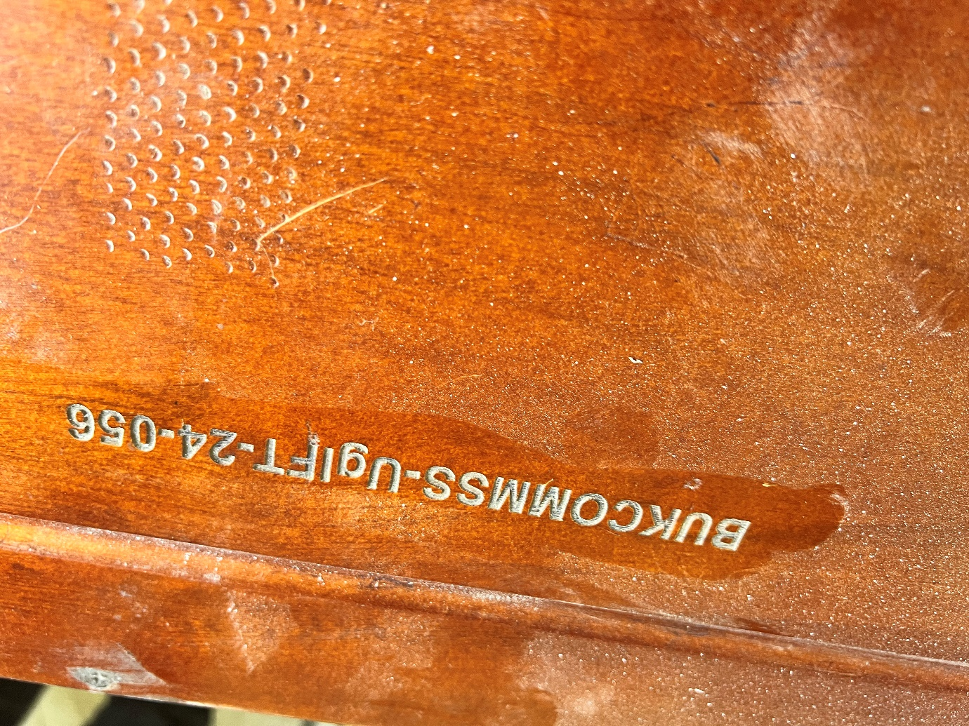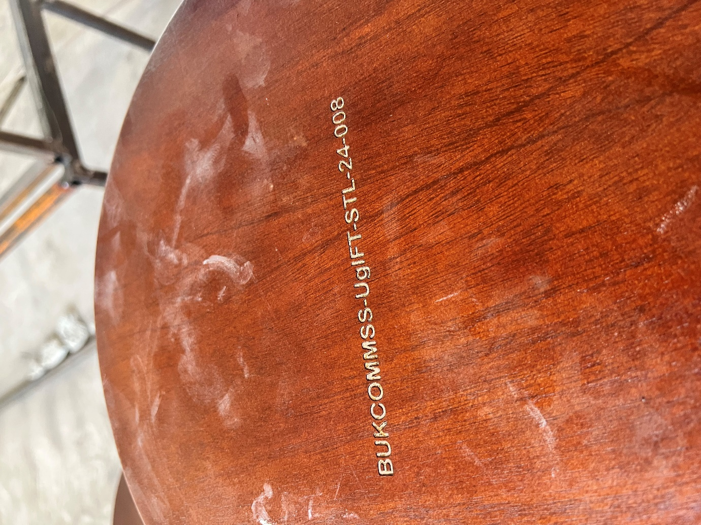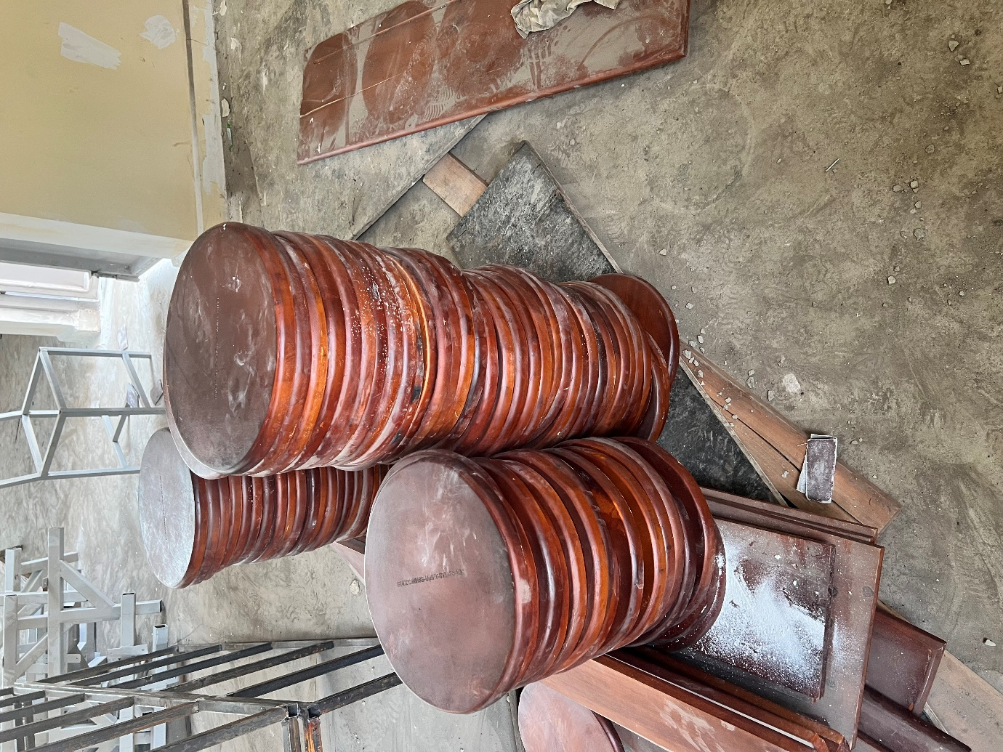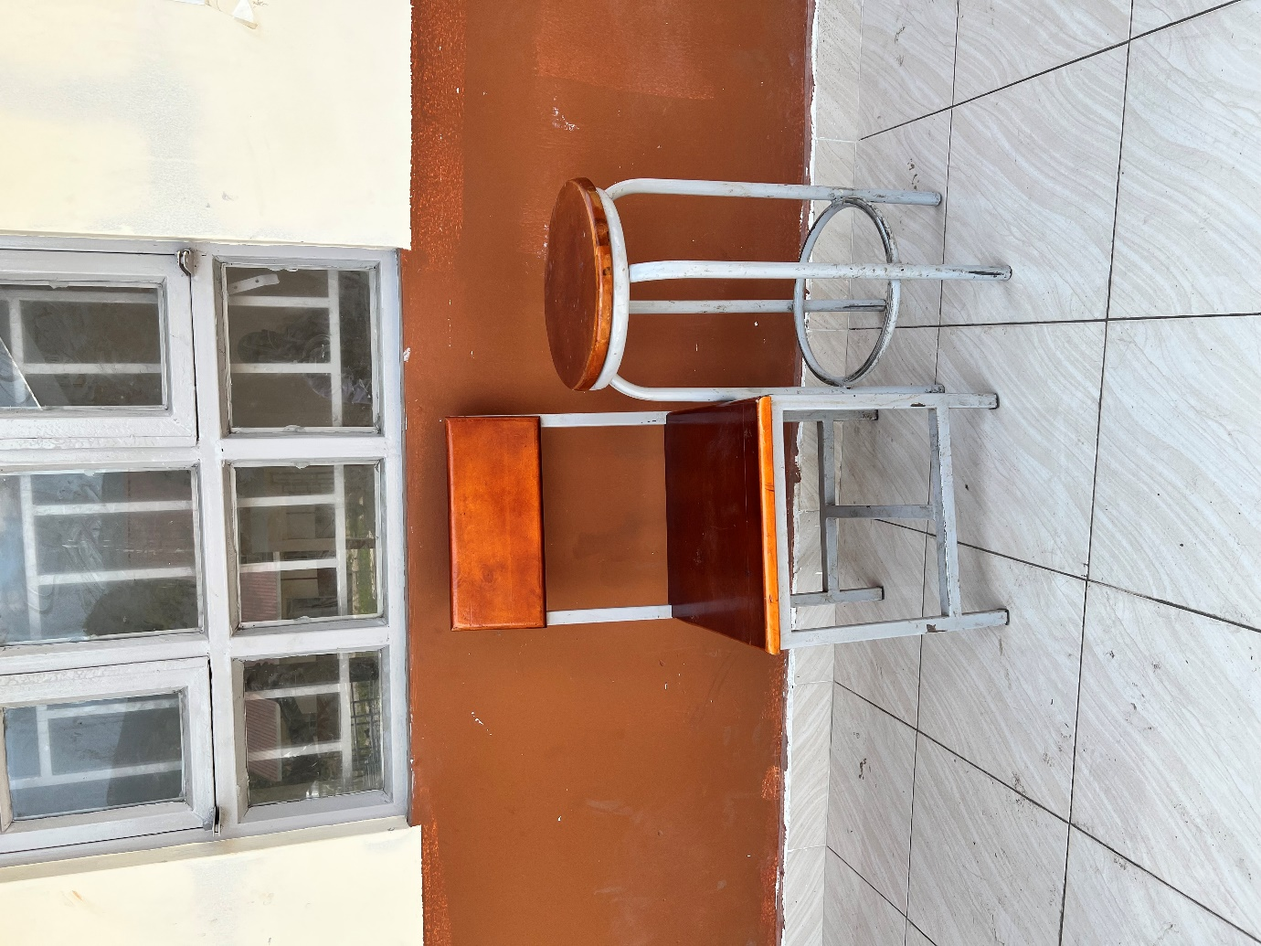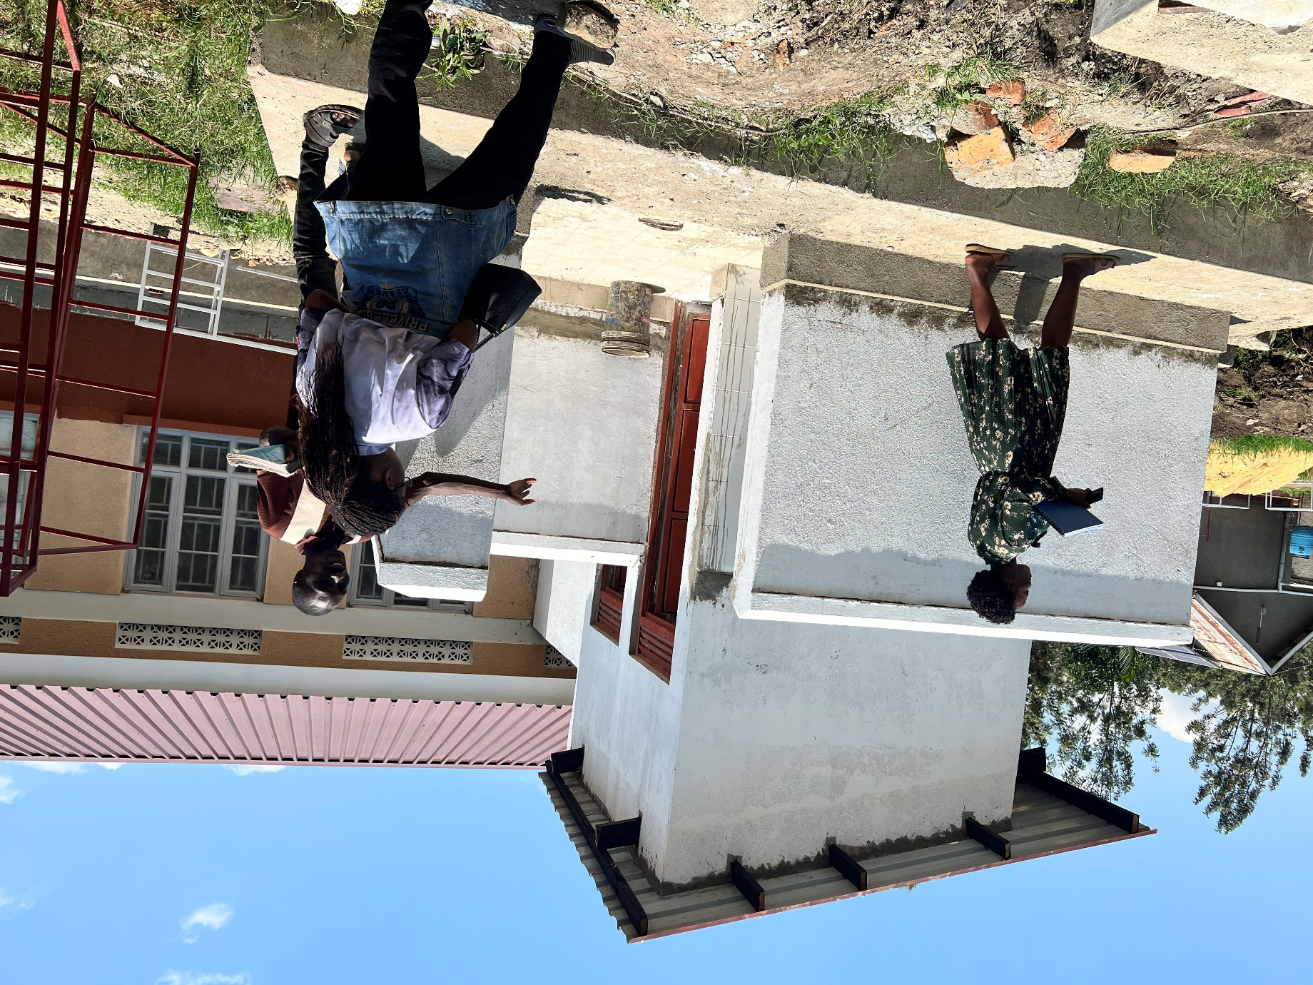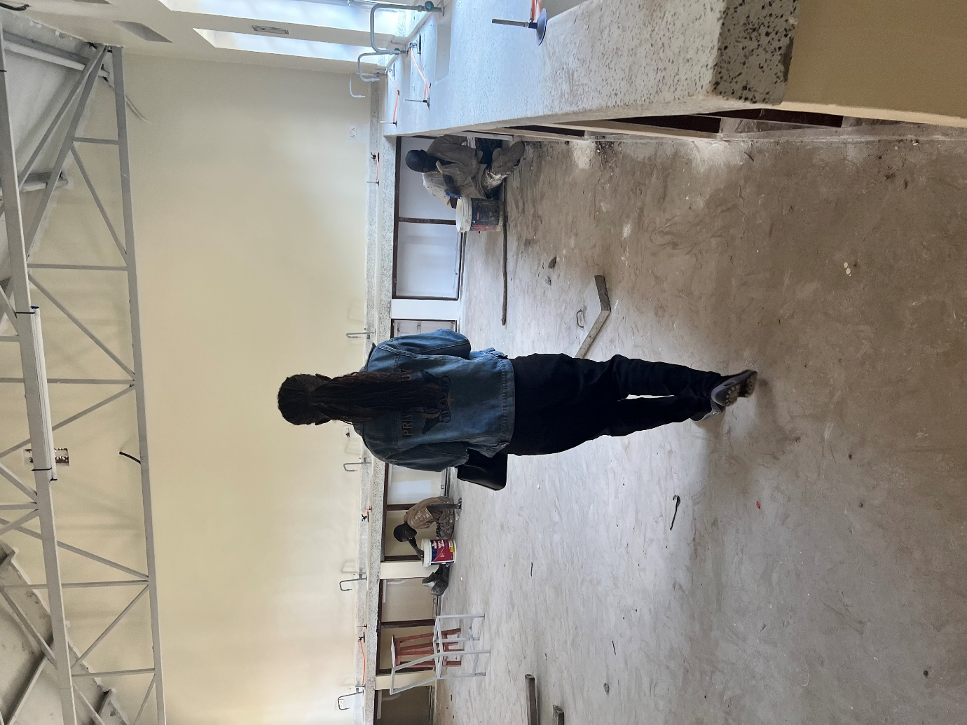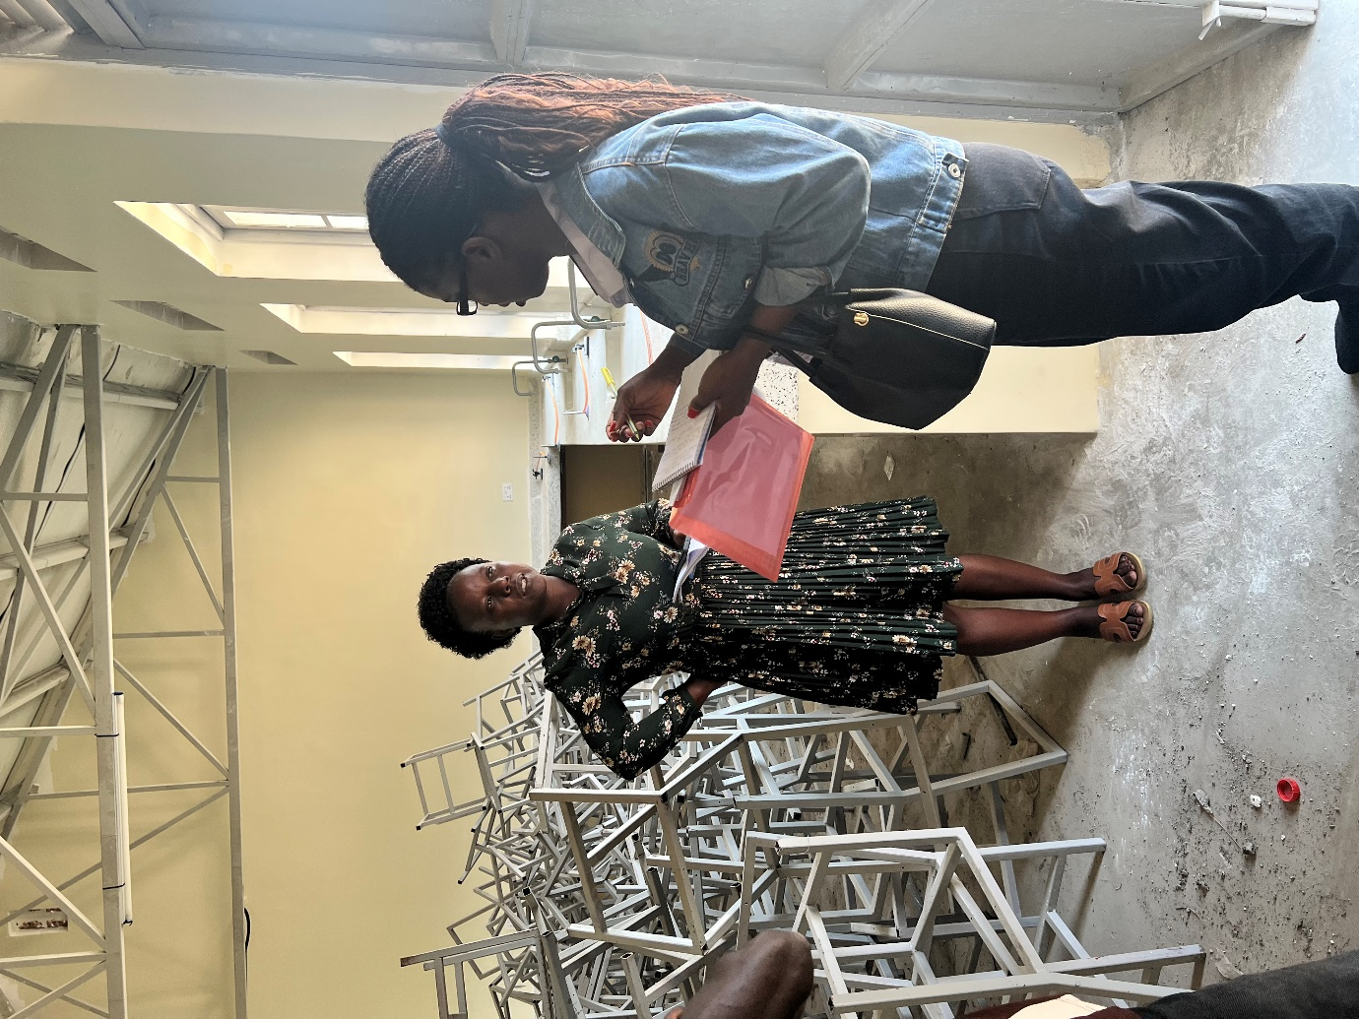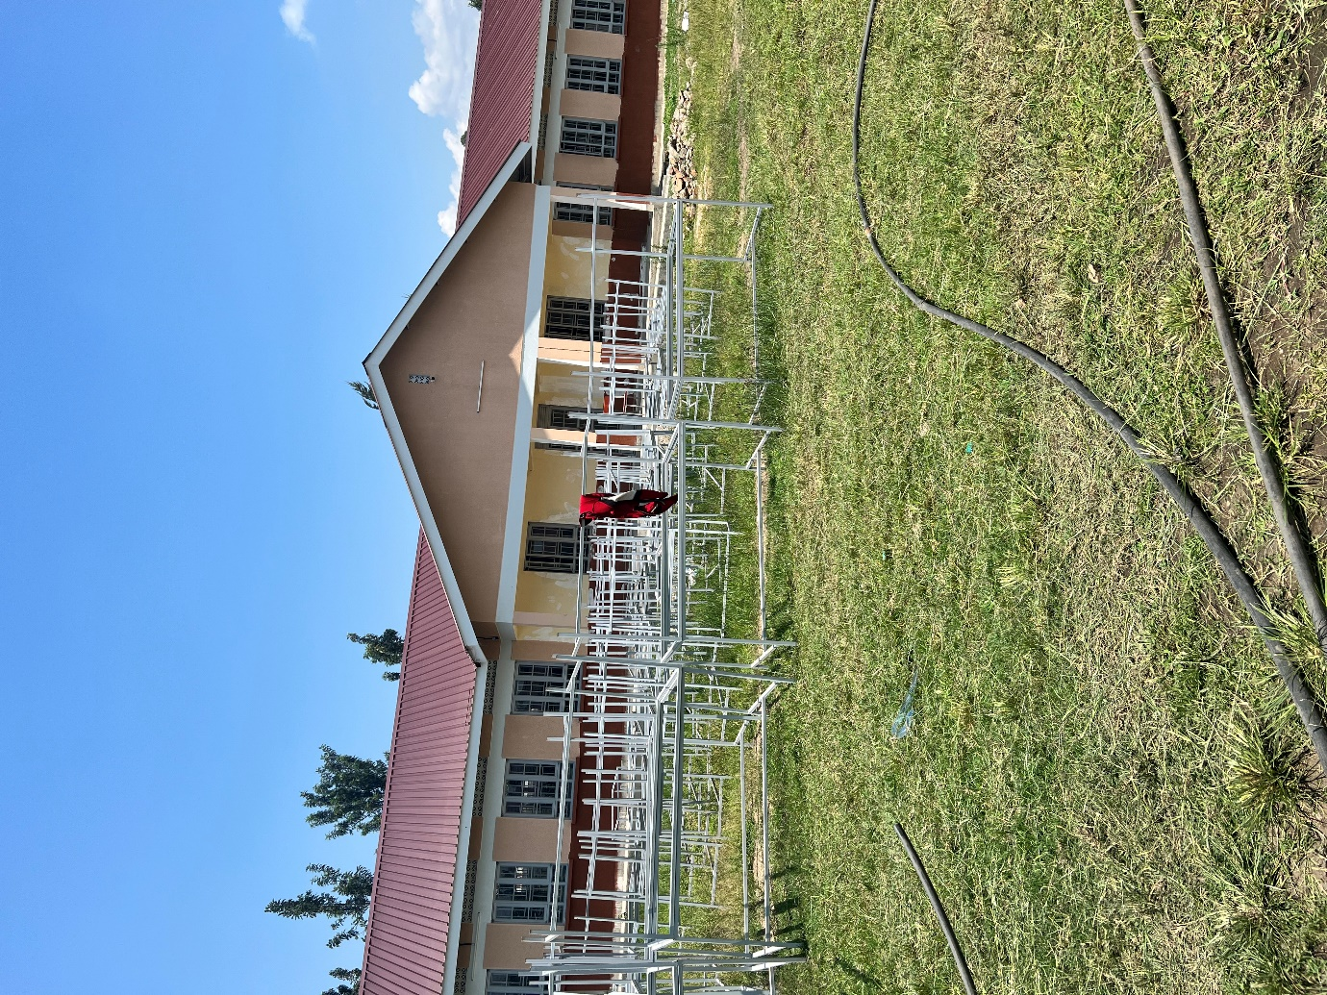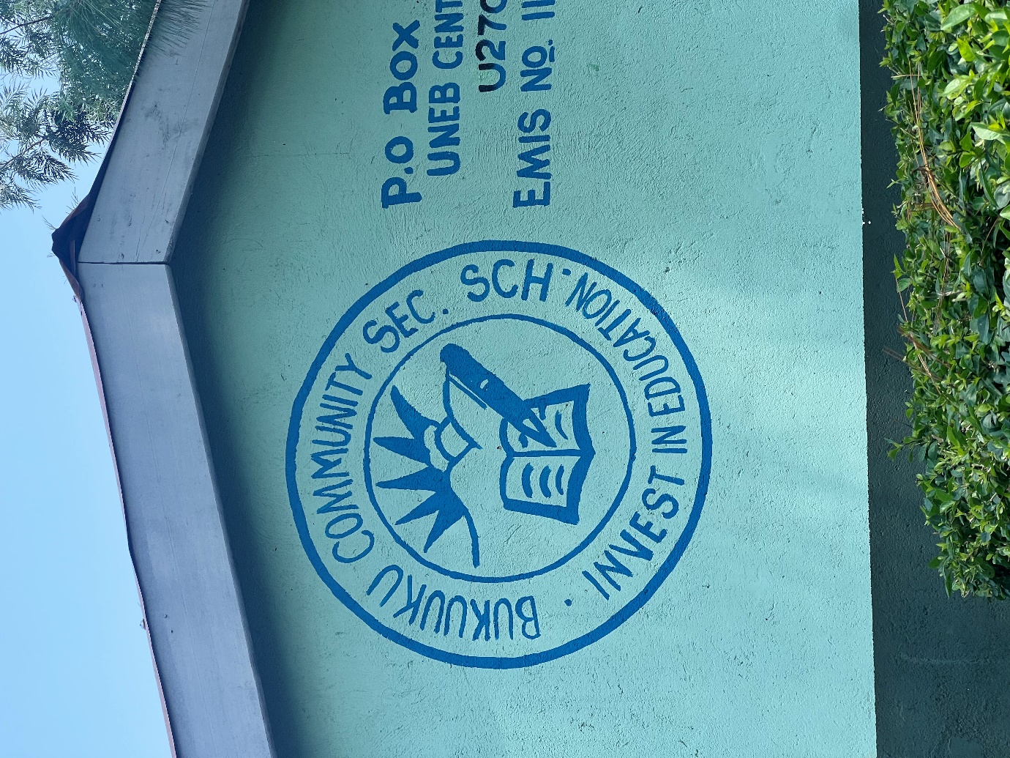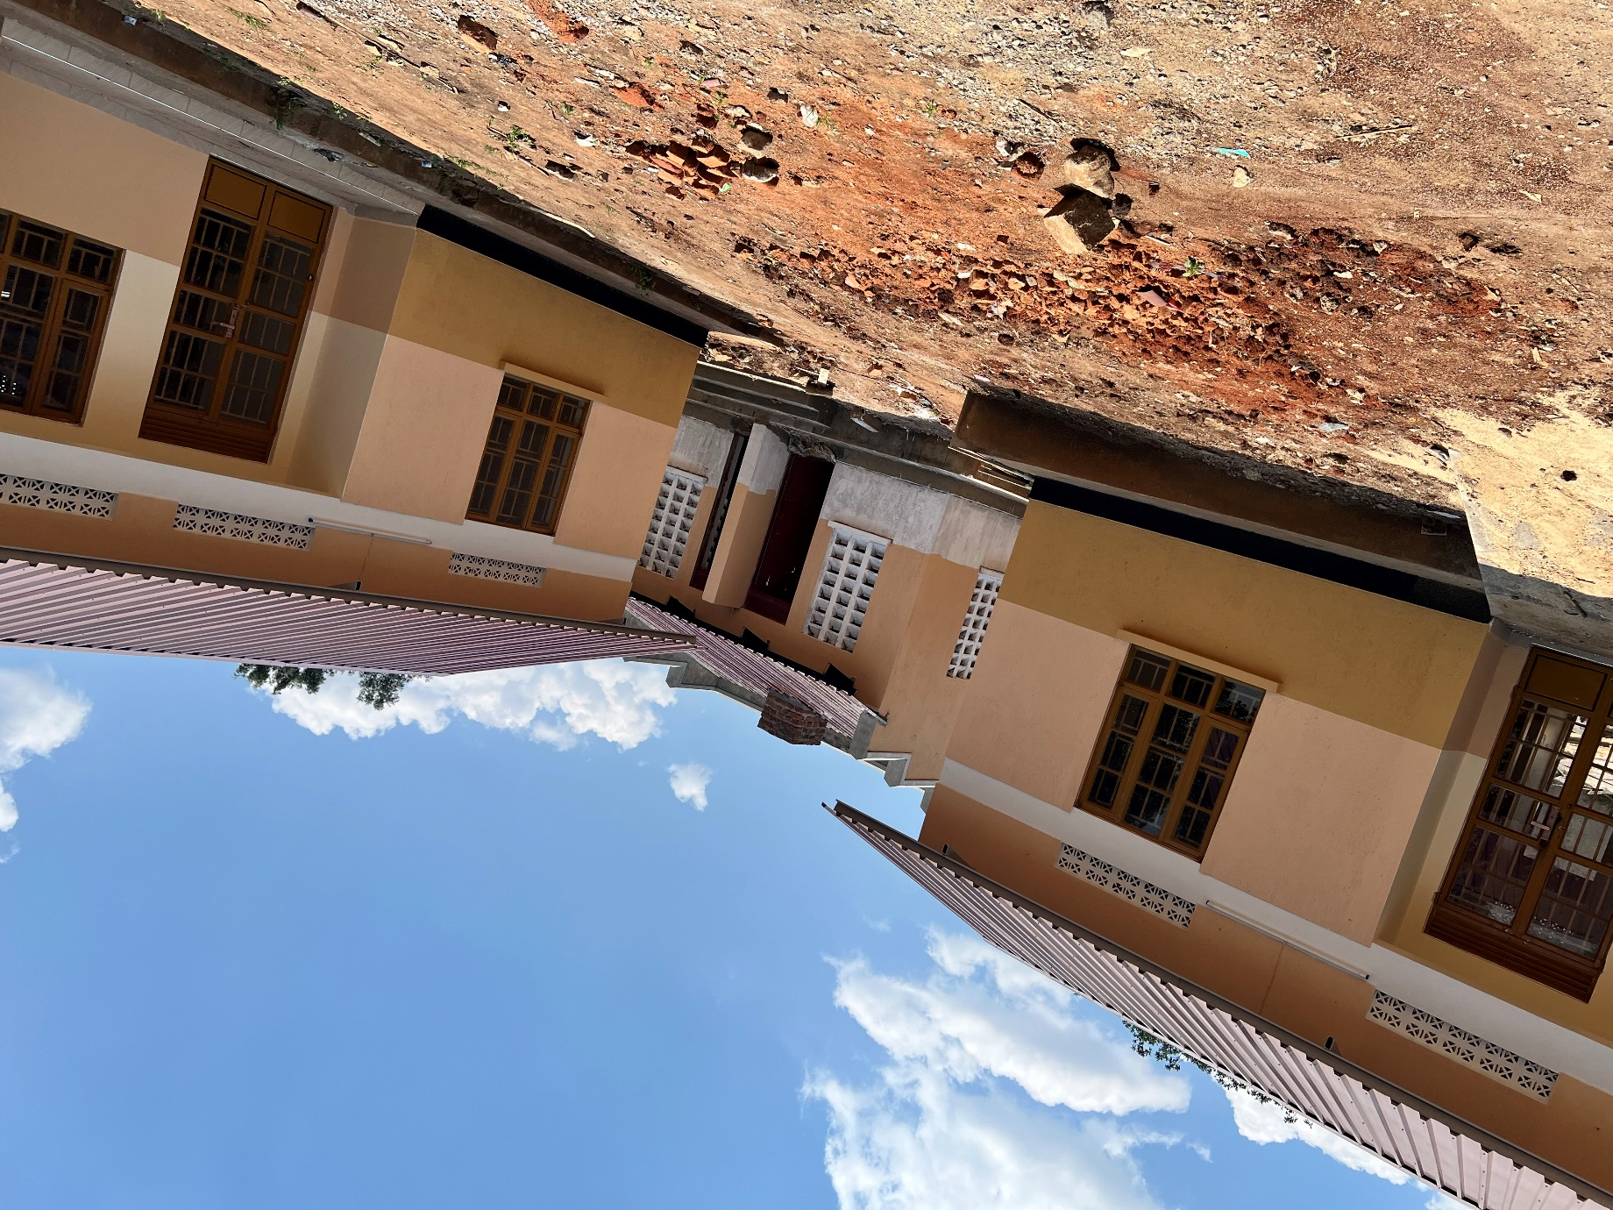
Well engraved desks
Well engraved stool tops
A sample of finished chair and a stool
Staff unfinished latrines
Inside the science laboratory with the unfinished chairs
Unfinished tables outside the science laboratory
Staff quarters

